Nepal College of Information Technology
Assessment
Fall 2010
Program: ELX/CE Time: 3 hrs
Semester: Fall FM: 100
Subject: MSI PM: 50

The figures in the margin indicate full marks.
Attempt all the questions:
1 a) Design a circuit to interface External memory 4K X 8 ROM and 2 K X 8 RAM with the 8051 microcontroller. [8]
b) What do you mean by addressing mode? Explain 8051 the various addressing modes with examples. [7]
2. a) How to sequence the instruction in 8051 microcontroller? Explain the JUMP and CALL instruction. [8]
b) Write a program and design a circuit that the INT1 pin is connected to a switch that is normally high. Whenever it goes low, it should turn on an LED. The LED is connected to P1.3 and is normally off. When it is turned on it should stay on for a fraction of a second. As long as the switch is pressed low, the LED should stay on. [7]
3. a) Write a 8051 Program to interface with 8255 [8]
i) Find the control byte for PA = in, PB = out, PC = out.
ii) Write a program to get data from PA and send it to both B and C.
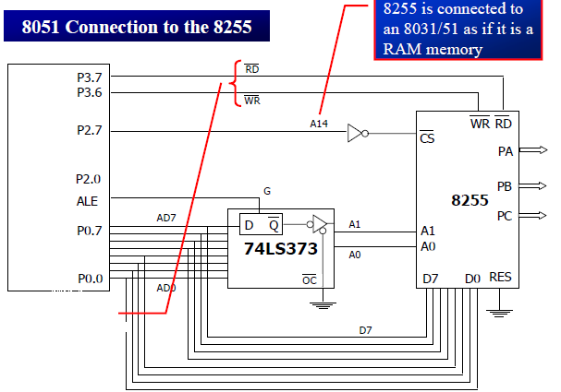
b) What is the significance of 8253 timer? Explain its various modes with timing diagram. [7]
4. a) What do you mean by Interrupt vector table ? How to respond the 16 interrupts by 8086 microprocessor? Explain with block diagram. [8]
b) Explain how printer port can be used for input and output operation. [7]
5. a) How can you measure the reliability of electronic component? Are there any processes to improve reliability? [8]
b) What is Ground bounce? Explain different types of grounding mechanism. [7]
6. a) What is Fault tolerance? Explain how shielding minimizes different types of noise coupling. [8]
b) What are the minimum signals you need to derive to interface devices in ISA and PCI bus? [7]
7. Write Short Notes (Any Two) [5*2=10]
a) Impedance Matching.
b) Line Filters, Isolators and Transient Suppressors
c) 8051 PSW registers

